Serial No.: [SERIAL NUMBER] | ✦ | Reg. No.: [REGISTRATION NO.]


[INSTITUTE / ORGANIZATION NAME]
— [ADDRESS / CAMPUS] —
[TAGLINE OR RECOGNITION STATEMENT]
This is to certify that
[RECIPIENT FULL NAME]

[S/O, D/O OR OTHER IDENTIFIER]
has successfully completed the requirements for the award of
❦ [QUALIFICATION / CERTIFICATE TITLE] ❦
[SPECIALIZATION / PROGRAM NAME]
This certificate is awarded in recognition of successful completion of the prescribed program and fulfillment of the applicable academic requirements.
Awarded in the year ✦ [YEAR] ✦
Given under the authority of [INSTITUTE / ORGANIZATION NAME], [LOCATION].
________________________  [AUTHORIZED SIGNATURE]  [TITLE / DESIGNATION] | 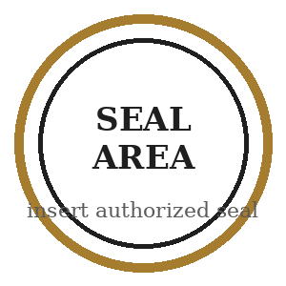 | ________________________  [AUTHORIZED SIGNATURE]  [TITLE / DESIGNATION]

Date of Issue: [DD MONTH YYYY] | Verification: [URL / CODE] | ┌────────┐  │ QR / │  │ VERIFY │  └────────┘

Replace all blue bracketed placeholders. This file is an editable layout sample and is not an official credential.

